ONLINE LIBRARY SYSTEM

SOFTWARE REQUIREMENTS SPECIFICATION

Software Requirements Specification

# Introduction

Borrowing books, returning books or viewing the available books at the Library of the local University is currently done manually where in the student has to go to the Library and check the available books at the Library. Students check the list of books available and borrow the books if the book is a borrow book otherwise it is of waste for the student to come to the library to come to check for the books if the student doesn’t get the book. Then the librarian checks the student id and allows the member to check out the book and the librarian then updates the member database and also the books database. This takes at least one to two hours if the member is available at the nearby place otherwise it may take more time.

We have decided to investigate the use of an Online Library Management System. This system would be used by members who may be students or professors of that University to check the availability of the books and borrow the books, and by the librarian to update the databases. The purpose of this document is to analyze and elaborate on the high-level needs and features of the *Online Library System***.** It focuses on the capabilities and facilities provided by a Library. The details of what all are the needs of the *Online Library System* and if it fulfils these needs are detailed in the use-case and supplementary specifications.

## Purpose

The purpose of **Software Requirements Specification (SRS)** document is to describe the external behavior of the Online Library System. Requirements Specification defines and describes the operations, interfaces, performance, and quality assurance requirements of the Online Library System. The document also describes the nonfunctional requirements such as the user interfaces. It also describes the design constraints that are to be considered when the system is to be designed, and other factors necessary to provide a complete and comprehensive description of the requirements for the software. The Software Requirements Specification (**SRS**) captures the complete software requirements for the system, or a portion of the system. Requirements described in this document are derived from the Vision Document prepared for the Online Library System.

## Scope

The Software Requirements Specification captures all the requirements in a single document. The *Online Library System* that is to be developed provides the members of the Library and employees of the library with books information, online blocking of books and many other facilities. The Online Library System is supposed to have the following features.

* The product provides the members with online blocking of books capabilities and the Online Library System is up and running all day.
* The system provides logon facility to the users.
* The system provides the members with the option to check their account and/or change their options like password of the account whenever needed all through the day during the library hours.
* The system allows the members to block the books 24 hours a day and all the through the semester.
* The system lets the library staff to check which all members have blocked the books and whether they can borrow any more books or not.
* The system allows the Librarian to create the books catalog, add/delete books and maintain the books catalog.
* The system updates the billing system as and when the member borrows or returns a book.
* The book catalog is automated and the decision of offering the book based on the category of the book is automatically decided.
* We also have an order department, which manages to add or remove a book from the Library.

The features that are described in this document are used in the future phases of the software development cycle. The features described here meet the needs of all the users. The success criteria for the system is based in the level up to which the features described in this document are implemented in the system.

## Definitions, Acronyms and Abbreviations

* OLS – Online Library System
* Provided wherever necessary in the document.
* PIN – Personal Identification Number

# Overall Description

* **Product Perspective**

1. The Online Library System is a package to be used by Libraries to improve the efficiency of Librarians, Library employees and Users. The Online Library System to be developed benefits greatly the members and the Librarian of University of Houston-Clearlake. The system provides books catalog and information to members and helps them decide on the books to borrow from the library. The Librarian can keep the books catalog updated all the time so that the members (students and the professors) get the updated information all the time.
2. The complete overview of the system is as shown in the overview diagram below
3. The product to be developed has interactions with the users: Librarian, Members who are the students and professors of the OLS.
4. The product has to interact with other systems like: Internet, Billing System and the OLS Information Security System.

 

**Billing System**

Librarian   
The Proposed Online Library

**OLS Information Security System**



Management System





**Internet**

**Users**

***Overview of the proposed system***

* **Product Functions**

1. The Online Library System provides online real time information about the books available in the Library and the user information. The Product functions are more or less the same as described in the product perspective. The functions of the system include the system providing different type of services based on the type of users [Member/Librarian].

1. The member should be provided with the updated information about the books catalog.
2. Provisions for the members to borrow the books they want, if all the other required rules hold good.
3. The member is given a provision to check his account information and change the account information any time in the given valid period.
4. The members are provided with the books available roster and allowed to choose the books, which they want to use in the coming up days.
5. The librarian can get the information about the members who have borrowed or returned the books.
6. The librarian is provided with interfaces to add/delete the books available in the book catalog.
7. The members when complete the book borrowing or returning process, the due to be paid by the member must be calculated and the information about the member and the due amount is sent to the university billing system.
8. The system uses the University information security requirements to provide the login facility to the users.

* **User characteristics**

1. The users of the system are members, librarian of the university and the administrators who maintain the system. The members and the librarian are assumed to have basic knowledge of the computers and Internet browsing. The administrators of the system to have more knowledge of the internals of the system and is able to rectify the small problems that may arise due to disk crashes, power failures and other catastrophes to maintain the system. The proper user interface, user’s manual, online help and the guide to install and maintain the system must be sufficient to educate the users on how to use the system without any problems.

* **Constraints**

1. The information of all the users must be stored in a database that is accessible by the Online Library System.
2. The university information security system must be compatible with the Internet applications.
3. The Online Library System is connected to the university computer and is running all 24 hours a day.
4. The users access the Online Library System from any computer that has Internet browsing capabilities and an Internet connection.
5. The billing system is connected to the Online Library System and the database used by the billing system must be compatible with the interface of the Online Library System.
6. The users must have their correct usernames and passwords to enter into the Online Library System.

* **Assumptions and dependencies**

1. The users have sufficient knowledge of computers.
2. The University computer should have Internet connection and Internet server capabilities.
3. The users know the English language, as the user interface will be provided in English
4. The product can access the university student database

# Specific Requirements

This section describes in detail all the functional requirements.

## Functionality

### Logon Capabilities

The system shall provide the users with logon capabilities.

### Mobile Devices

The Online Library System is also supported on mobile devices such as cell phones.

### Alerts

The system can alert the Librarian or the administrator in case of any problems.

## Usability

* The system shall allow the users to access the system from the Internet using HTML or it’s derivative technologies. The system uses a web browser as an interface.
* Since all users are familiar with the general usage of browsers, no specific training is required.
* The system is user friendly and self-explanatory.

## Performance

### Response Time

The Splash Page or Information page should be able to be downloaded within a minute using a 56K modem. The information is refreshed every two minutes. The access time for a mobile device should be less than a minute. The system shall respond to the member in not less than two seconds from the time of the request submittal. The system shall be allowed to take more time when doing large processing jobs.

### Administrator/Librarian Response

The system shall take as less time as possible to provide service to the administrator or the librarian.

### Throughput

The number of transactions is directly dependent on the number of users, the users may be the Librarian, employees of the library and also the people who use the library for checking-out books, returning books and checking online library account.

### Capacity

The system is capable of handling 250 users at a time.

### Resource Utilization

The resources are modified according the user requirements and also according to the books requested by the users.

## Supportability

The system designers shall take into considerations the following supportability and technical limitations.

### Internet Protocols

The system shall be complied with the TCP/IP protocol standards and shall be designed accordingly.

### Information Security Requirement

The system shall support the OLS information security requirements and use the same standard as the OLS information security requirements.

### Billing System Data Compatibility

The member balance amount that will be calculated and sent to the billing system shall be compatible with the data types and design constraints of the billing system.

### Maintenance

The maintenance of the system shall be done as per the maintenance contract.

### Standards

The coding standards and naming conventions will be as per the American standards.

## Design Constraints

### Software Language Used

The languages that shall be used for coding the Online Library System are Java, Servlets, Java Server Pages (JSP), HTML, JavaScript, and ReactJs. For working on the coding phase of the Online Library System, the Tomcat Server needs to be installed.

### Development Tools

For Java: Spring Tool Suite

Webserver: Tomcat

Build: Maven

Database: MySql

### Technology Used:

1. Spring Boot for Rest Web Services.
2. ReactJS as Front End.
3. Spring Boot for Business Components
4. Spring Data JPA for Database.
5. Tomcat For Web Server
6. Maven for Building Project.
7. Junit and Mockito for Testing.
8. Postman for testing Rest API.

## Interfaces

### User Interfaces

Will make use of the existing Web Browsers such as Microsoft Internet Explorer or Netscape. The user-interface of the system shall be designed as shown in the user-interface prototypes.

***Logon Screen Prototype:***

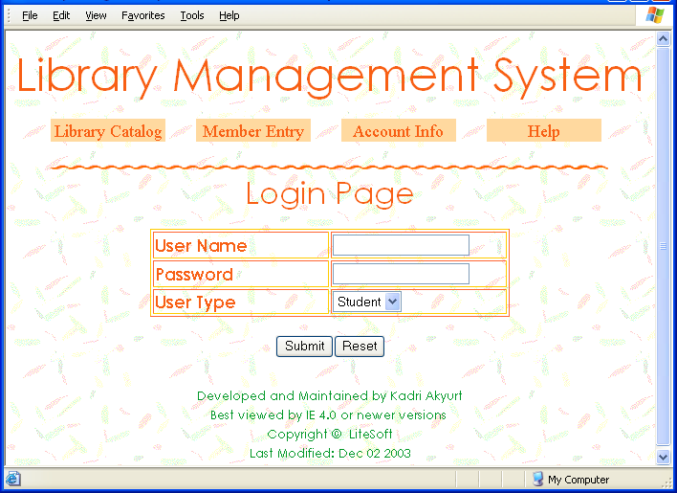

***Home Page Of OLS Library Prototype:***

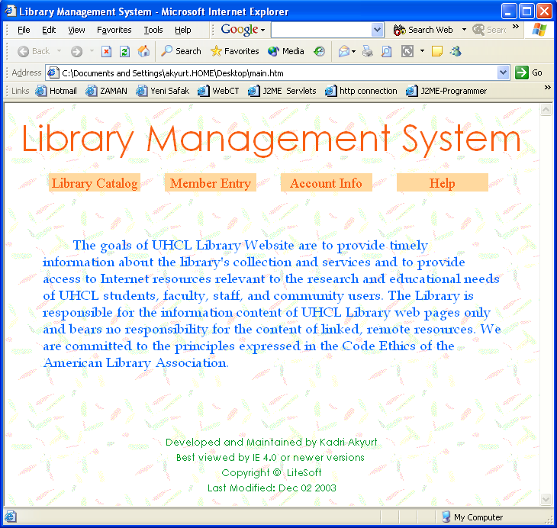

***Member Registration Screen:***

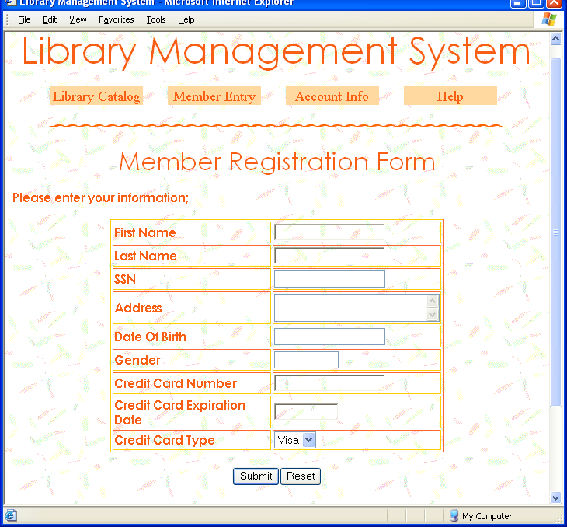

***Member Information once Logged in:***

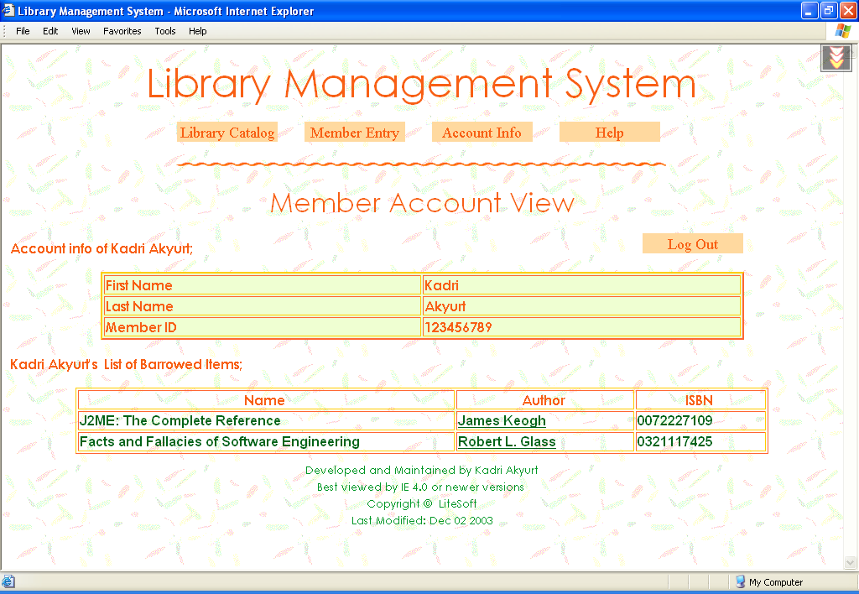

***Main Search Page of Library Catalog:***

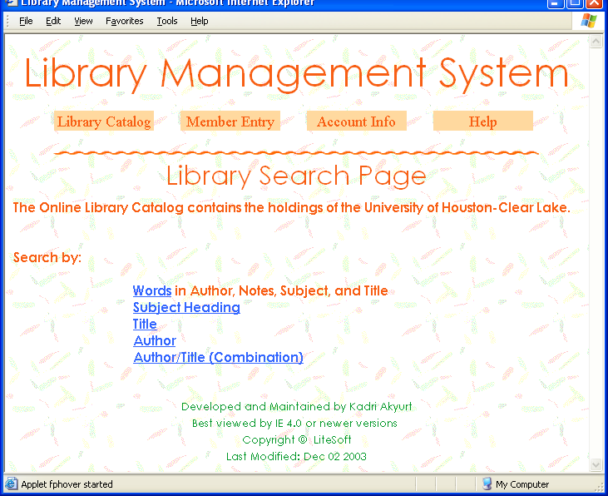

### Hardware Interfaces

The existing Local Area Network (LAN) will be used for collecting data from the users and also for updating the Library Catalogue.

### Software Interfaces

A firewall will be used with the server to prevent unauthorized access to the system.

### Communications Interfaces

The Online Library System will be connected to the World Wide Web.